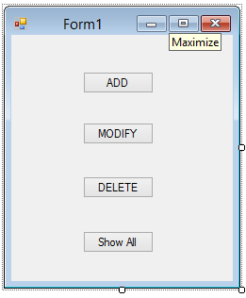

Public Class Form1

Private Sub Button1_Click(ByVal sender As System.Object, ByVal e As System.EventArgs) Handles AddButton.Click

Dim frm = New NameForm()

frm.ShowDialog()

End Sub

Private Sub Form1_Load(ByVal sender As System.Object, ByVal e As System.EventArgs) Handles MyBase.Load

End Sub

Private Sub ModifyButton_Click(ByVal sender As System.Object, ByVal e As System.EventArgs) Handles ModifyButton.Click

Dim frm = New ModifyForm()

frm.ShowDialog()

End Sub

Private Sub DeleteButton_Click(ByVal sender As System.Object, ByVal e As System.EventArgs) Handles DeleteButton.Click

Dim frm = New DeleteForm()

frm.ShowDialog()

End Sub

Private Sub Button4_Click(ByVal sender As System.Object, ByVal e As System.EventArgs) Handles Button4.Click

Dim frm = New ShowAllForm()

frm.Show()

End Sub

End Class

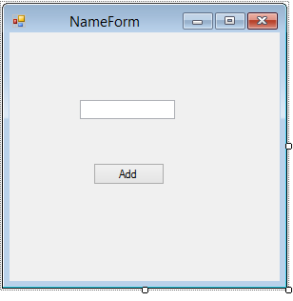

Imports System.Data.SqlClient

Public Class NameForm

Private Sub AddButton_Click(ByVal sender As System.Object, ByVal e As System.EventArgs) Handles AddButton.Click

Dim conn As SqlConnection = New SqlConnection("Data Source=SAKSHI\MSSQLEXPRESS12;Initial Catalog=somedb;Integrated Security=True")

conn = New SqlConnection("Data Source=SAKSHI\MSSQLEXPRESS12;Initial Catalog=somedb;Integrated Security=True")

Dim adapter = New SqlDataAdapter("SELECT * FROM student", conn)

Dim ds = New DataSet()

adapter.Fill(ds, "student")

Dim row = ds.Tables(0).NewRow()

row("name") = NameTextBox.Text

ds.Tables(0).Rows.Add(row)

Dim cmdBuilder = New SqlCommandBuilder(adapter)

adapter.InsertCommand = cmdBuilder.GetInsertCommand()

adapter.Update(ds.Tables(0))

MsgBox("Row added")

Me.Close()

End Sub

End Class

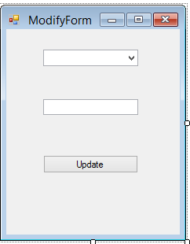

Imports System.Data.SqlClient

Imports System.Data

Imports System.Data.Sql

Public Class ModifyForm

Dim conn As SqlConnection

Dim cmdBuilder As SqlCommandBuilder

Dim adapter As SqlDataAdapter

Dim ds As DataSet

Private Sub ComboBox1_SelectedIndexChanged(ByVal sender As System.Object, ByVal e As System.EventArgs) Handles IdComboBox.SelectedIndexChanged

Dim id = ""

id = IdComboBox.SelectedItem

Dim sel = String.Format("id = " & id)

Dim row = ds.Tables(0).Select(sel).First()

NameTextBox.Text = row("name")

End Sub

Private Sub UpdateButton_Click(ByVal sender As System.Object, ByVal e As System.EventArgs) Handles UpdateButton.Click

conn = New SqlConnection("Data Source=SAKSHI\MSSQLEXPRESS12;Initial Catalog=somedb;Integrated Security=True")

Dim id = ""

id = IdComboBox.SelectedItem

Dim sel = String.Format("id = " & id)

Dim row = ds.Tables(0).Select(sel).First()

row("name") = NameTextBox.Text

cmdBuilder = New SqlCommandBuilder(adapter)

adapter.UpdateCommand = cmdBuilder.GetUpdateCommand()

adapter.Update(ds.Tables(0))

MsgBox("Row Updated")

Me.Close()

conn.Close()

End Sub

Private Sub ModifyForm_Load(ByVal sender As System.Object, ByVal e As System.EventArgs) Handles MyBase.Load

conn = New SqlConnection("Data Source=SAKSHI\MSSQLEXPRESS12;Initial Catalog=somedb;Integrated Security=True")

conn = New SqlConnection("Data Source=SAKSHI\MSSQLEXPRESS12;Initial Catalog=somedb;Integrated Security=True")

adapter = New SqlDataAdapter("SELECT * FROM student", conn)

ds = New DataSet()

adapter.Fill(ds, "student")

For Each row In ds.Tables(0).Rows

IdComboBox.Items.Add(row("id"))

Next

End Sub

End Class

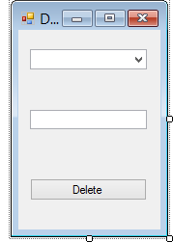

Imports System.Data.SqlClient

Public Class DeleteForm

Dim conn As SqlConnection

Dim cmdBuilder As SqlCommandBuilder

Dim ds As DataSet

Dim adapter As SqlDataAdapter

Private Sub IdComboBox_SelectedIndexChanged(ByVal sender As System.Object, ByVal e As System.EventArgs) Handles IdComboBox.SelectedIndexChanged

conn = New SqlConnection("Data Source=SAKSHI\MSSQLEXPRESS12;Initial Catalog=somedb;Integrated Security=True")

Dim id = ""

id = IdComboBox.SelectedItem

Dim sel = String.Format("id = " & id)

Dim row = ds.Tables(0).Select(sel).First()

NameTextBox.Text = row("name")

End Sub

Private Sub DeleteForm_Load(ByVal sender As System.Object, ByVal e As System.EventArgs) Handles MyBase.Load

conn = New SqlConnection("Data Source=SAKSHI\MSSQLEXPRESS12;Initial Catalog=somedb;Integrated Security=True")

adapter = New SqlDataAdapter("SELECT * FROM student", conn)

ds = New DataSet()

adapter.Fill(ds, "student")

For Each row In ds.Tables(0).Rows

IdComboBox.Items.Add(row("id"))

Next

End Sub

Private Sub UpdateButton_Click(ByVal sender As System.Object, ByVal e As System.EventArgs) Handles UpdateButton.Click

conn = New SqlConnection("Data Source=SAKSHI\MSSQLEXPRESS12;Initial Catalog=somedb;Integrated Security=True")

Dim id = ""

id = IdComboBox.SelectedItem

Dim sel = String.Format("id = " & id)

Dim row = ds.Tables(0).Select(sel).First()

row.Delete() ' Not ds.Tables(0).Rows.Remove(row)

cmdBuilder = New SqlCommandBuilder(adapter)

adapter.DeleteCommand = cmdBuilder.GetDeleteCommand(True)

MsgBox(adapter.DeleteCommand.Parameters(0).ToString())

adapter.Update(ds.Tables(0))

MsgBox("Row Deleted")

Me.Close()

conn.Close()

End Sub

End Class

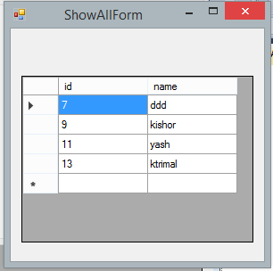

Imports System.Data.SqlClient

Public Class ShowAllForm

Dim conn

Dim cmd

Private Sub ShowAllForm_Load(ByVal sender As System.Object, ByVal e As System.EventArgs) Handles MyBase.Load

Dim conn = New SqlConnection("Data Source=SAKSHI\MSSQLEXPRESS12;Initial Catalog=somedb;Integrated Security=True")

Dim adapter = New SqlDataAdapter("SELECT * FROM student", conn)

Dim ds = New DataSet()

adapter.Fill(ds, "student")

DataGridView1.DataSource = ds.Tables(0)

End Sub

Private Sub DataGridView1_CellContentClick(ByVal sender As System.Object, ByVal e As System.Windows.Forms.DataGridViewCellEventArgs) Handles DataGridView1.CellContentClick

End Sub

End Class